Assignment 2

* General Data Set distribution
  + **All samples are taken from labels that have more than 1 image – the reason is because if we use an image from label that has only one image it will not help the model to learn from this specific image in respect to similarity (only non-similarity obviously)**
  + Test Data set as partial of the General DB
    - Containing 500 sample of ‘same’ pairs
    - Containing 500 sample of ‘ not same’ pairs
  + Train Data set as partial of the General DB
    - Containing 1100 sample of ‘same’ pairs
    - Containing 1100 sample of ‘ not same’ pairs
* 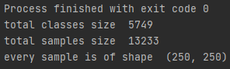
* 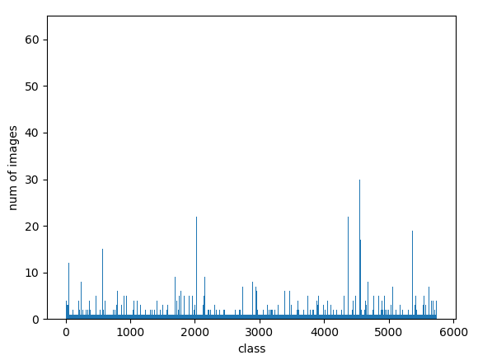

Notes:

* Used as reverence the VGG architecture (first few layers) since images are with similar size (224^2) trained on ImageNet DB and our images are also in the same domain (faces)
  + Main idea taken form the VGG is to decrease the size of every feature map and to increase the depth (# maps) on ever layer progress…
* Foreach twin’s net used final activations as Sigmoid as described in Paper, all other activation are RELU similar to VGG

Incremental Improvements:

* Added BN and Model started to learn Val_acc = 65% before that the Validation loss almost did not improved
* Started with Weights initialization from N(0,0.01) got accuracy on Validation set ~ 0.625
* Set to Xavier weight initialization and improved marginally on first epochs, and converge is faster fewer epochs.
* After Neural Net was stable and we started to fine tune it was decided to use Test set for validation (epochs) due to few data + this way we will get Test results on every epoch and can decide when to stop
* Added learning regularization l = 0.95*l boosted a bit
* Adding last CONV (depth 256 🡺 512) boosted by 2% accuracy (VGG from)
* In general, Cross-entropy will calculate a score that summarizes the average difference between the actual and predicted probability for class 1 (explanation for loss Func choosing)
* After using all CONV padding as ‘same’ inspired by VGG tried doing without padding on the non first CONV 2 layer (it is recommended to have ‘same’ padding at least in the first CONV layer in computer vision problems.)
* ~~we are interesting in the Epoch that has the lowest loss and not the highest accuracy, that is because the final task is to give an answer for which label from~~ **~~N labels~~** ~~is best describing the tested image and that is calculated by~~
  + ~~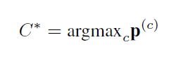so we care lass if we make wrong decision on few single prediction where the correct answer is ‘pair is deferent’ what we care is that maximum value p is at the correct label among all different labels~~
* Best epoch ‘7’
* 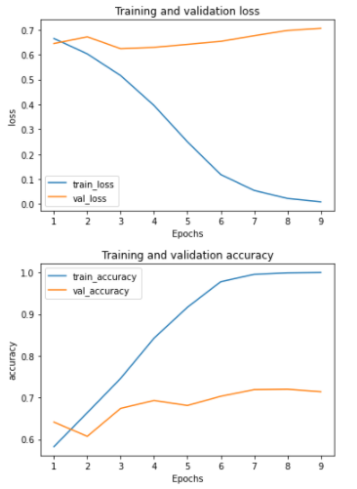

Epoch 1/9

275/275 - 111s - loss: 0.6649 - accuracy: 0.5823 - val_loss: 0.6447 - val_accuracy: 0.6410

Epoch 2/9

275/275 - 104s - loss: 0.6030 - accuracy: 0.6636 - val_loss: 0.6717 - val_accuracy: 0.6070

Epoch 3/9

275/275 - 105s - loss: 0.5161 - accuracy: 0.7459 - val_loss: 0.6238 - val_accuracy: 0.6740

Epoch 4/9

275/275 - 104s - loss: 0.3959 - accuracy: 0.8423 - val_loss: 0.6293 - val_accuracy: 0.6930

Epoch 5/9

275/275 - 104s - loss: 0.2502 - accuracy: 0.9164 - val_loss: 0.6412 - val_accuracy: 0.6810

Epoch 6/9

275/275 - 104s - loss: 0.1185 - accuracy: 0.9777 - val_loss: 0.6534 - val_accuracy: 0.7030

Epoch 7/9

275/275 - 105s - loss: 0.0548 - accuracy: 0.9955 - val_loss: 0.6761 - val_accuracy: 0.7190

Epoch 8/9

275/275 - 105s - loss: 0.0226 - accuracy: 0.9991 - val_loss: 0.6971 - val_accuracy: 0.7200

Epoch 9/9

275/275 - 105s - loss: 0.0091 - accuracy: 1.0000 - val_loss: 0.7058 - val_accuracy: 0.7140